Matthew Prendergast - s5283740

**MAIN TREAP (KEY + PRIORITY)**

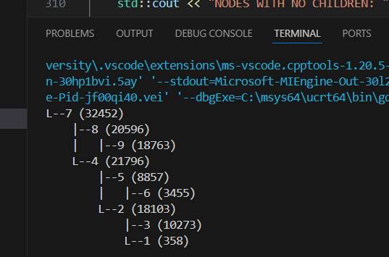

**REDESIGNED BY HAND (PRIORITY)**

7 (32452)

/ \

4 (21796) 8 (20596)

/ \ \

2 (18103) 5 (8857) 9 (18763)

/ \ \

1 (358) 3 (10273) 6 (3455)

**1.**

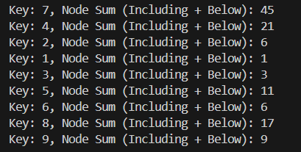

**REDESIGNED BY HAND (SUM)**

7 (45)

/ \

4 (21) 8 (17)

/ \ \

2 (6) 5 (11) 9 (9)

/ \ \

1 (1) 3 (3) 6 (6)

**2.**

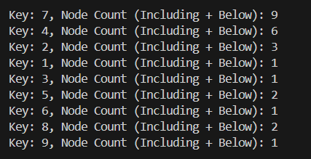

**REDESIGNED BY HAND (COUNT)**

7 (9)

/ \

4 (6) 8 (2)

/ \ \

2 (3) 5 (2) 9 (1)

/ \ \

1 (1) 3 (1) 6 (1)

**3, 4, 5.**

**REDESIGNED BY HAND (0 = GREEN, 1 = RED, 2 = BLUE)**

7 (9)

/ \

4 (6) 8 (2)

/ \ \

2 (3) 5 (2) 9 (1)

/ \ \

1 (1) 3 (1) 6 (1)

ENTIRE SCREENSHOT

